AWS Challenge
Challenge: Setting Up AWS Transit Gateway and VPC Endpoints for a Multi-VPC Architecture
Objective:
To design and implement a scalable AWS network architecture using AWS Transit Gateway (TGW) to interconnect multiple VPCs and configure VPC Endpoints for secure, private access to AWS services (such as Amazon S3) without using Internet Gateways or NAT Gateways.

Prerequisites
- AWS Account
- AWS Management Console access
- IAM permissions to create:
  - VPCs
  - Transit Gateway
  - Transit Gateway Attachments
  - Route Tables
  - VPC Endpoints
- Three existing VPCs (or create them during the lab)
- Non-overlapping CIDR blocks

Step-by-Step Procedure

Step 1: Create Multiple VPCs
Create three VPCs.
1. Create VPC with name Application-VPC and CIDR 10.1.0.0/16
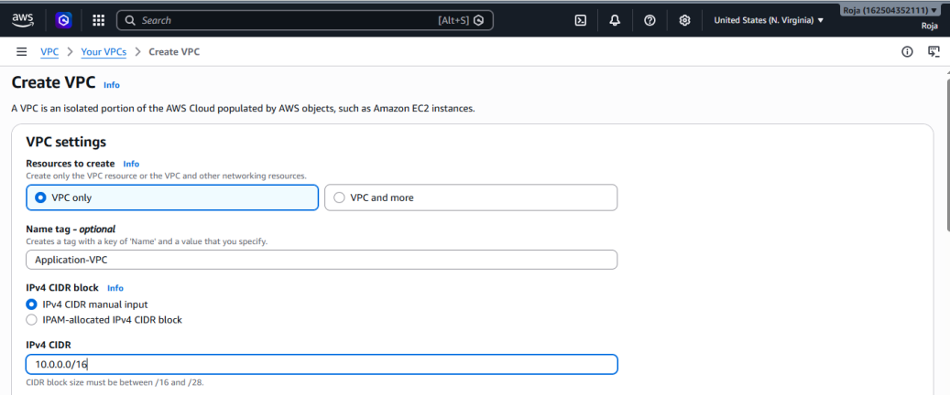

Successfully created First VPC:
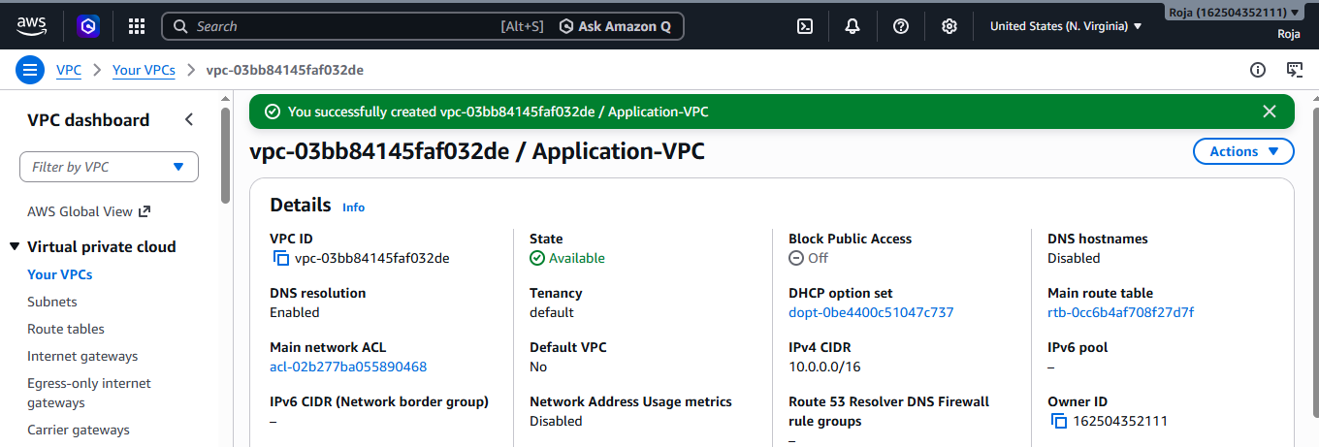
2. Create VPC with name Database VPC and CIDR: 10.1.0.0/16
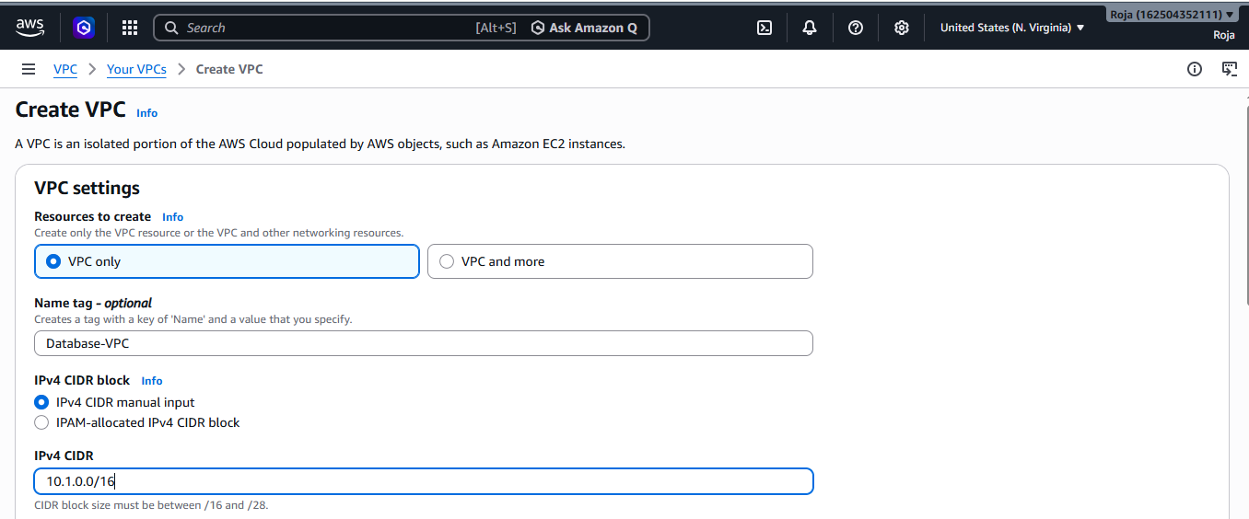
Successfully created Second VPC:
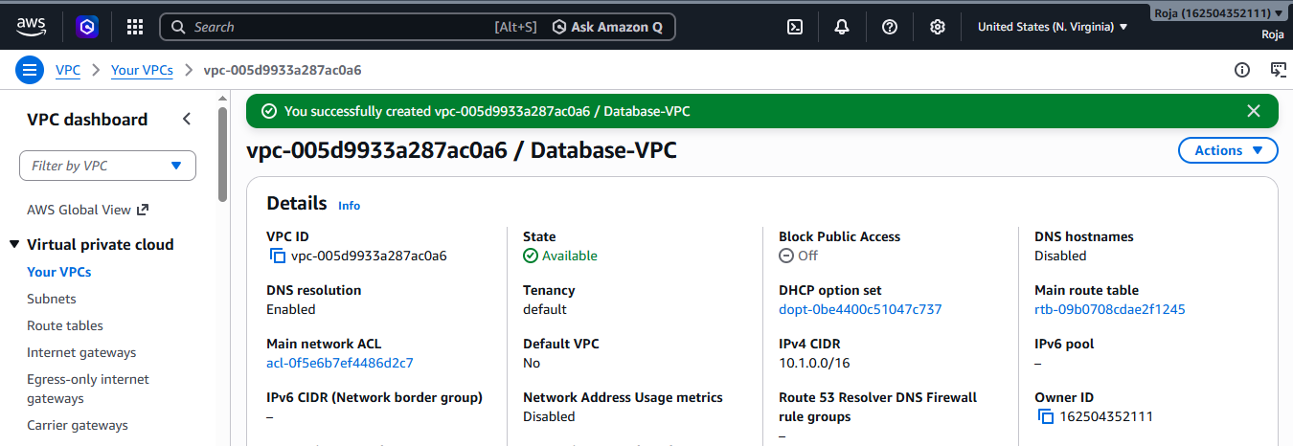

3. Created VPC with name Shared services VPC and CIDR: 10.2.0.0/16
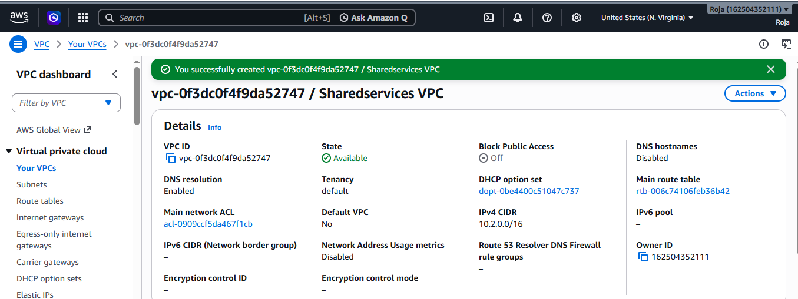

Step 2: Create public subnet in each VPC:

Created Public subnet in VPC 1:
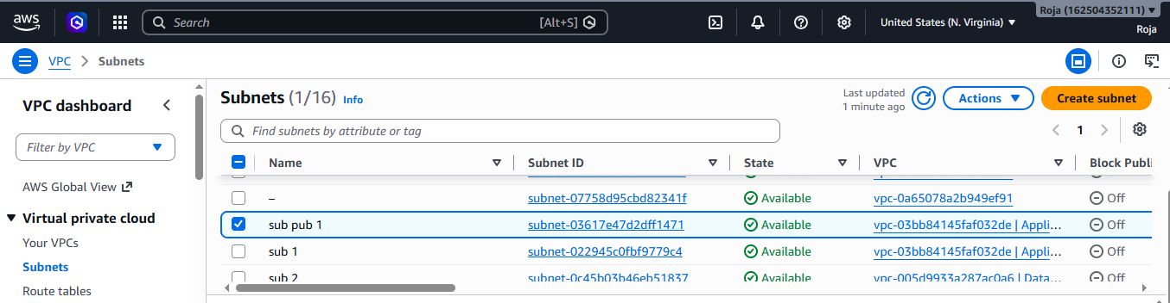

Created Public Subnet in VPC 2:
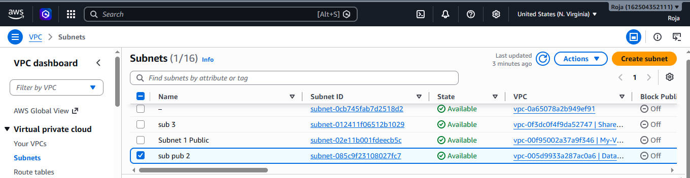

Created Public subnet in VPC 3:
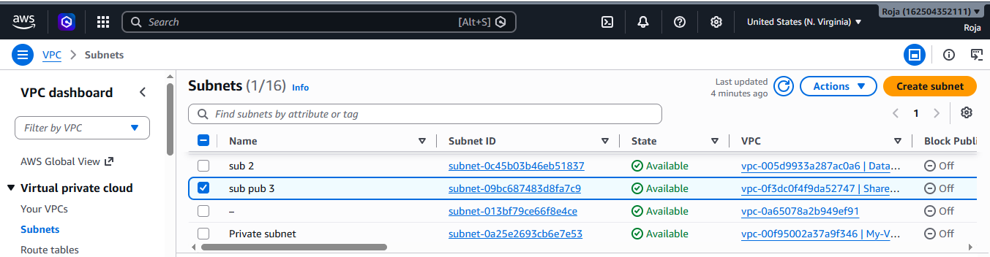

Step 3: Create Internet Gateways
Create an Internet Gateway for each VPC.
Attach each Internet Gateway to its respective VPC.

Created Internet gateway-01 and attached to VPC1
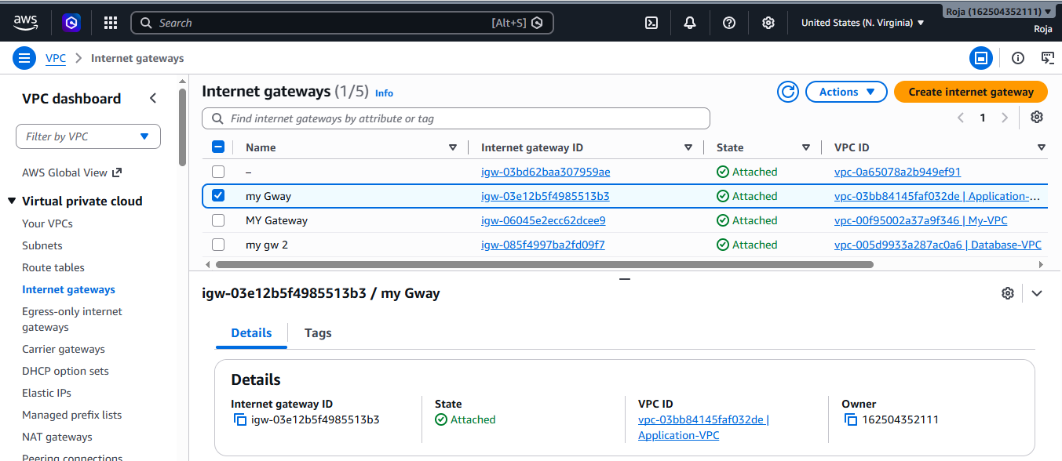

Created Internet Gateway-02 and attached to VPC2:
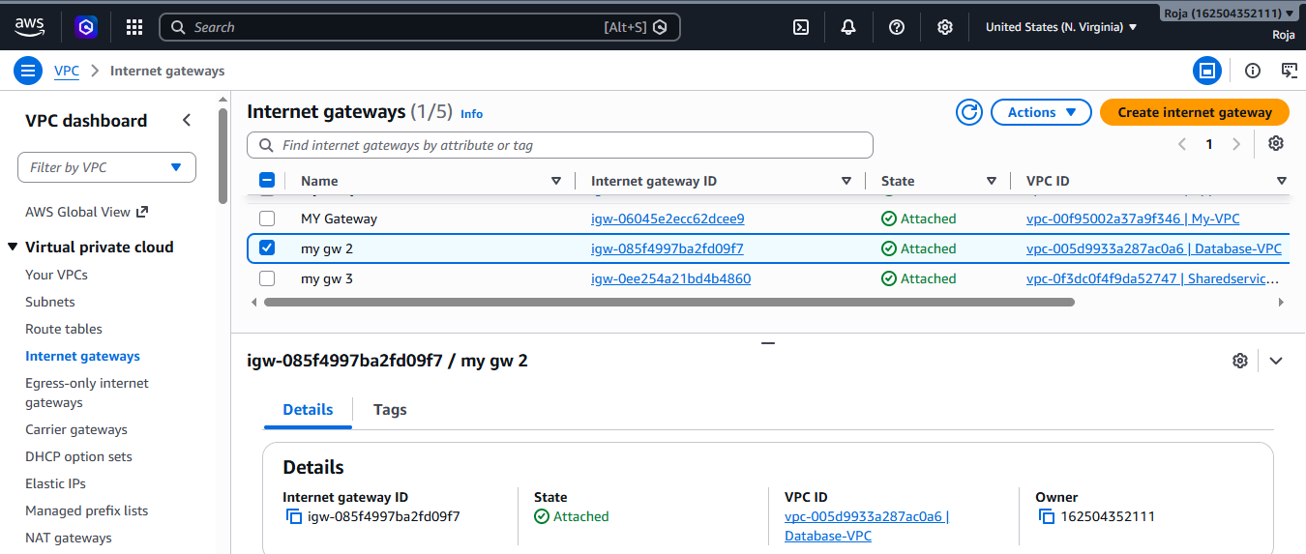

Created Internet Gateway-03 and attached to VPC3:
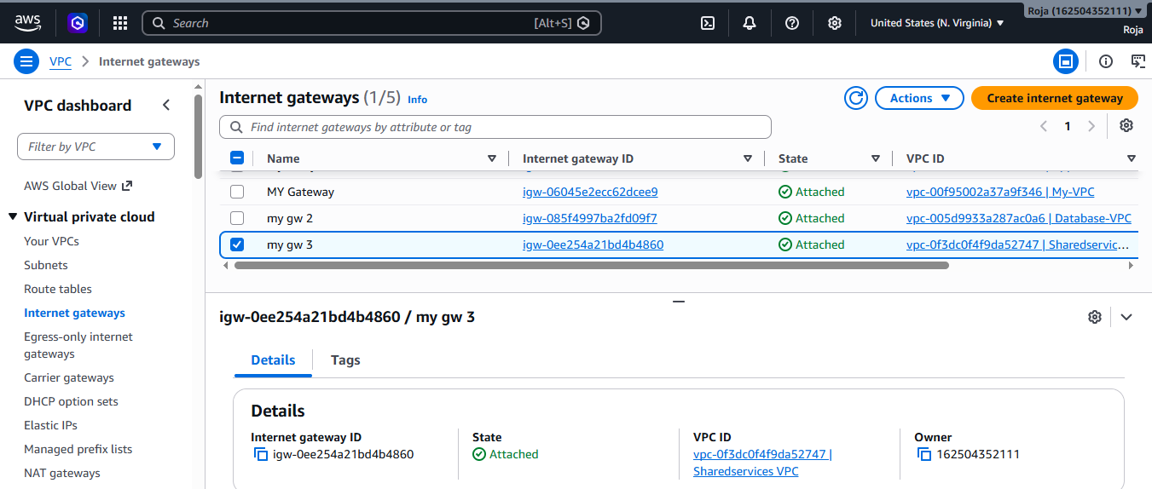

Step 4: Configure Route Tables

Each VPC route table should contain Internet Gateway

Associate the public subnet with the route table.

Added route in RT-1 with Internet Gateway:

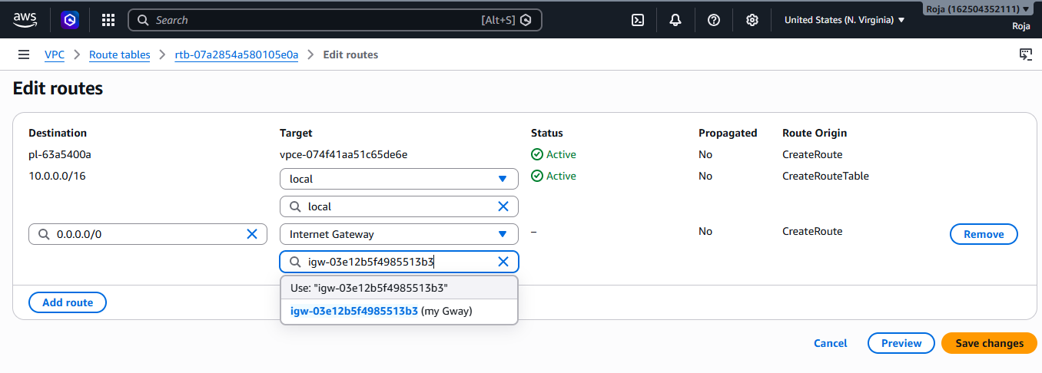

Associated the public Subnet with route table RT-1:

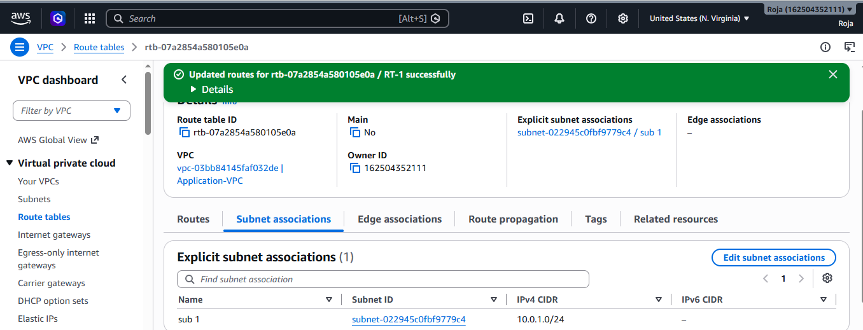

Added route in RT-2 with Internet Gateway:

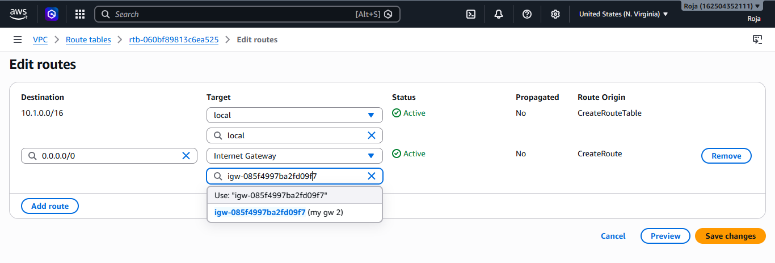

Associated the public Subnet with route table RT-2:

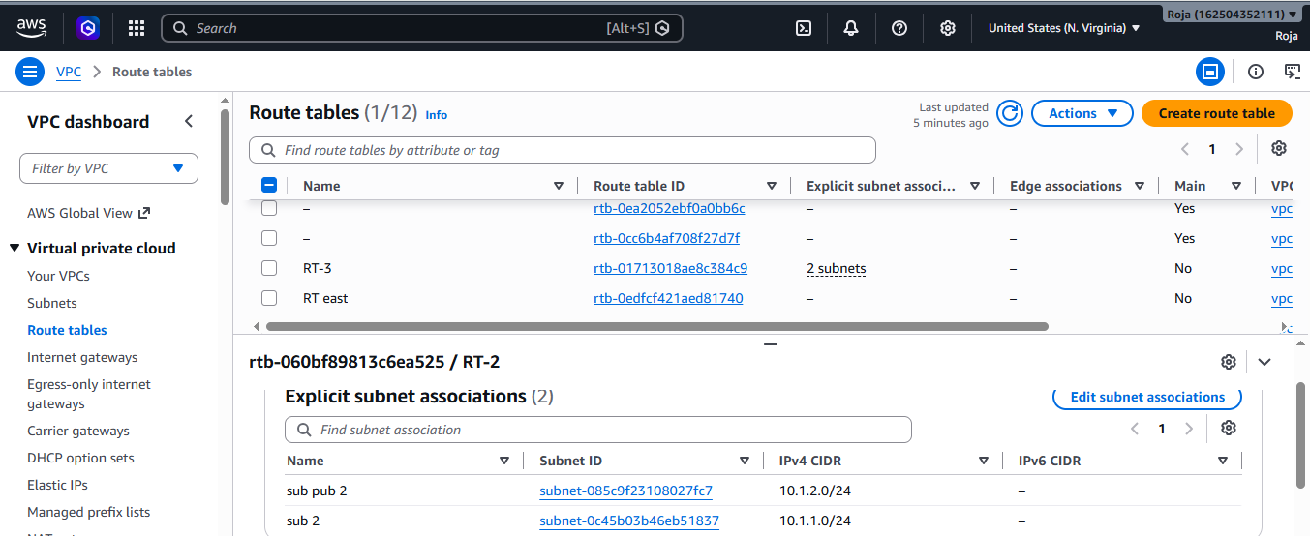

Added route in RT-3 with Internet Gateway:

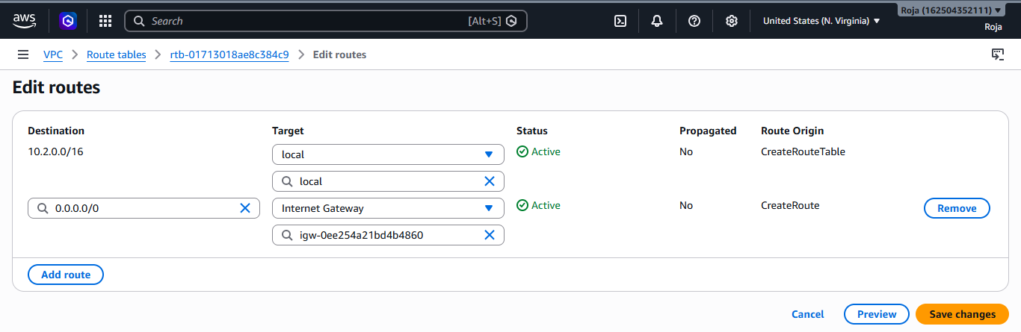

Associated the public Subnet with route table RT-3:

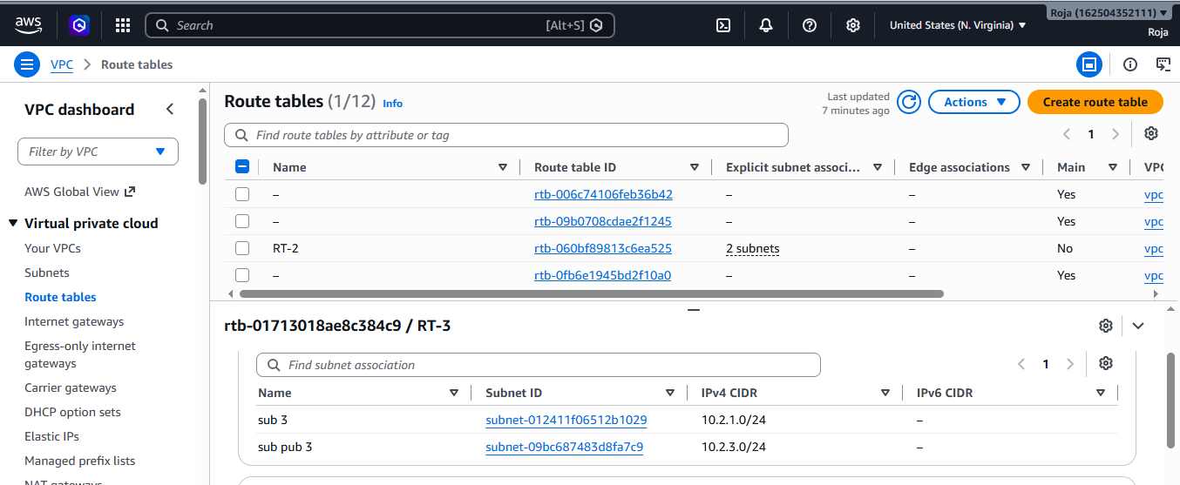

Step 5: Create an AWS Transit Gateway
- Open VPC Dashboard.
- Select Transit Gateways.
- Click Create Transit Gateway.

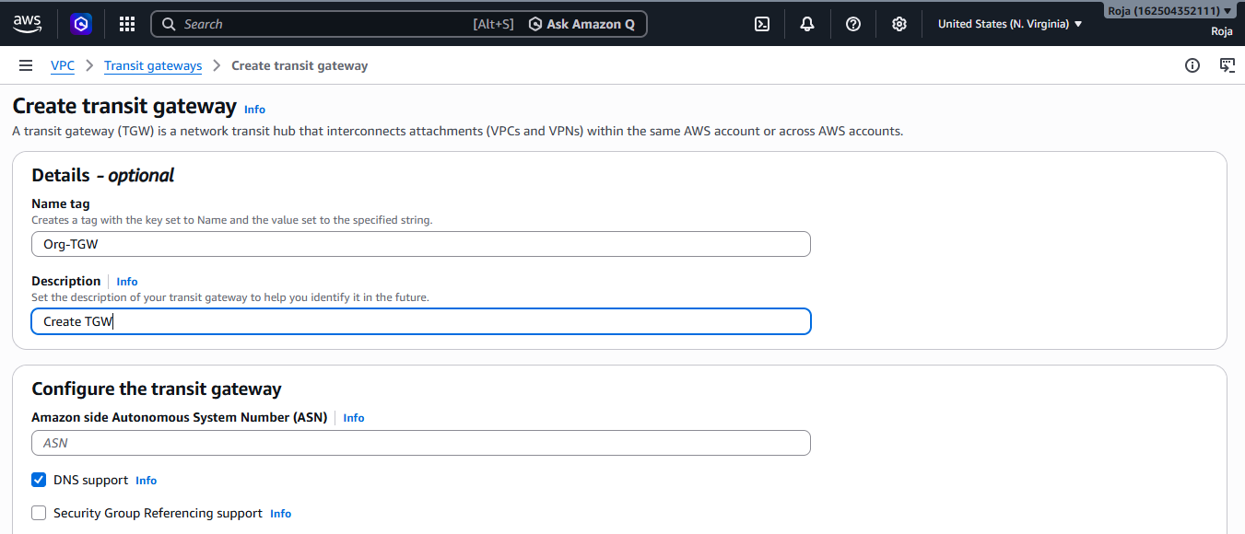
Created Transit gateway
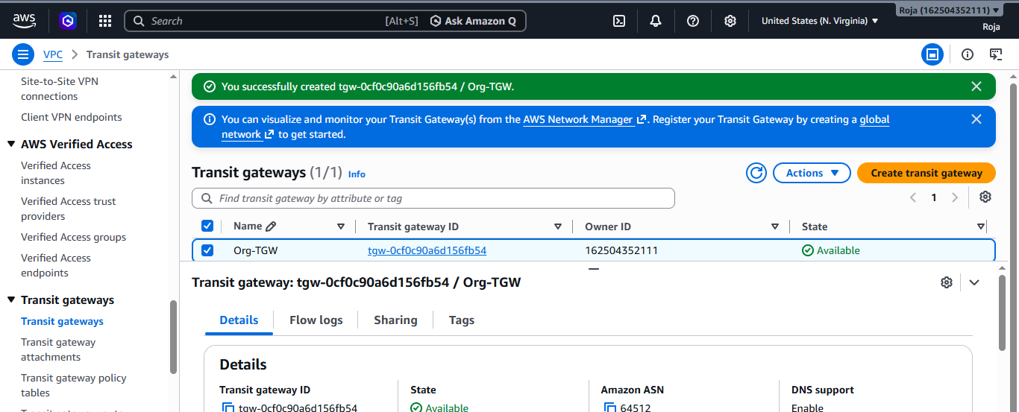

Step 6: Create Transit Gateway Attachments
Repeat for each VPC.
- Select Transit Gateway Attachments.
- Click Create Attachment.

Created Attachment 1 for Transit Gateway:
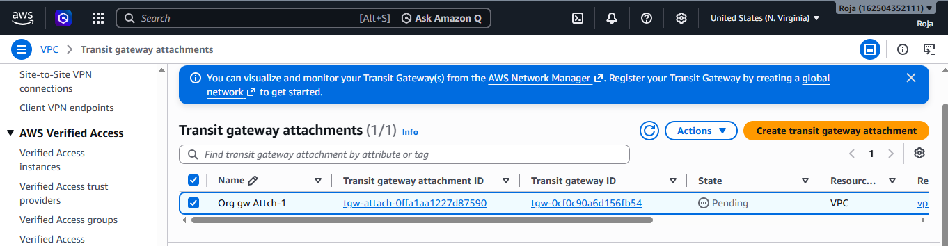
Created Attachment 2 for Transit Gateway:
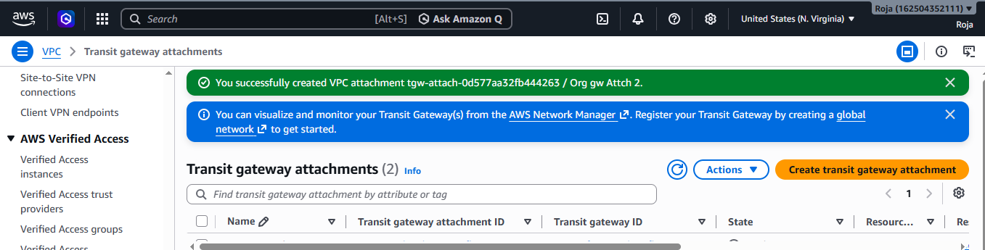
Created Attachment 3 for Transit Gateway
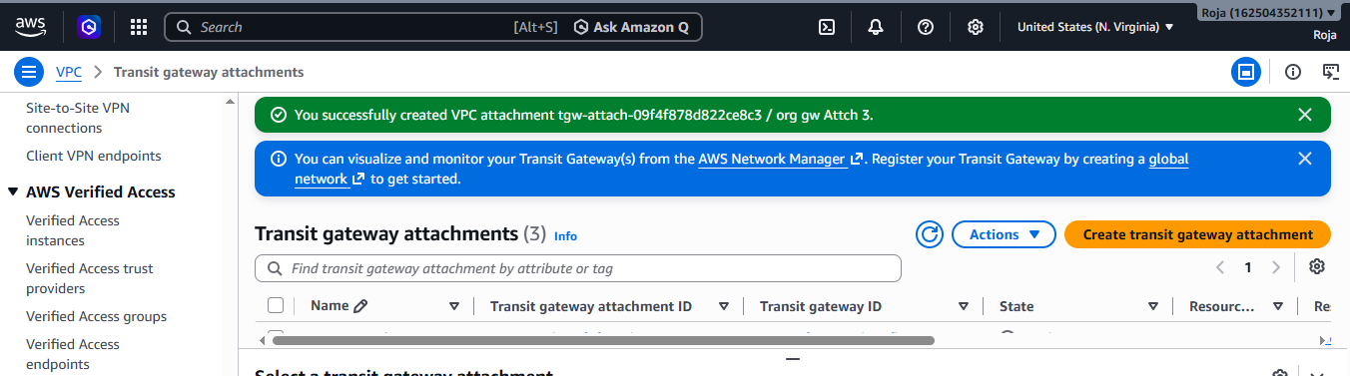
Step-7 Update VPC route tables:
Update Route table-1 for VPC 1
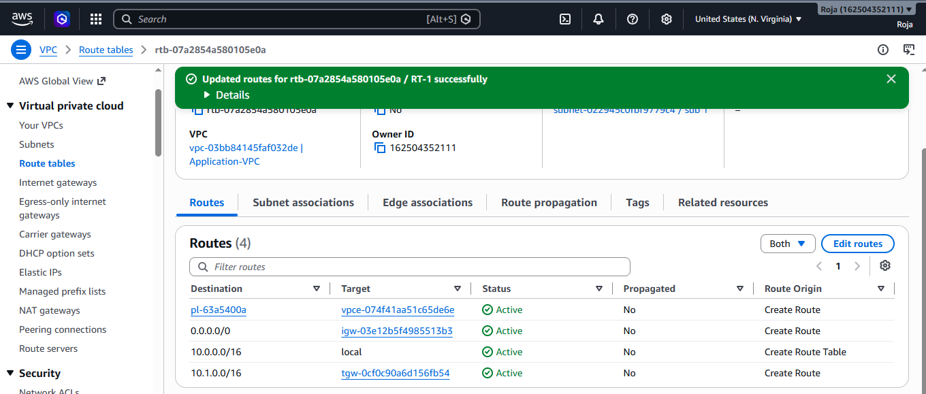
Update Route table-2 for VPC 2
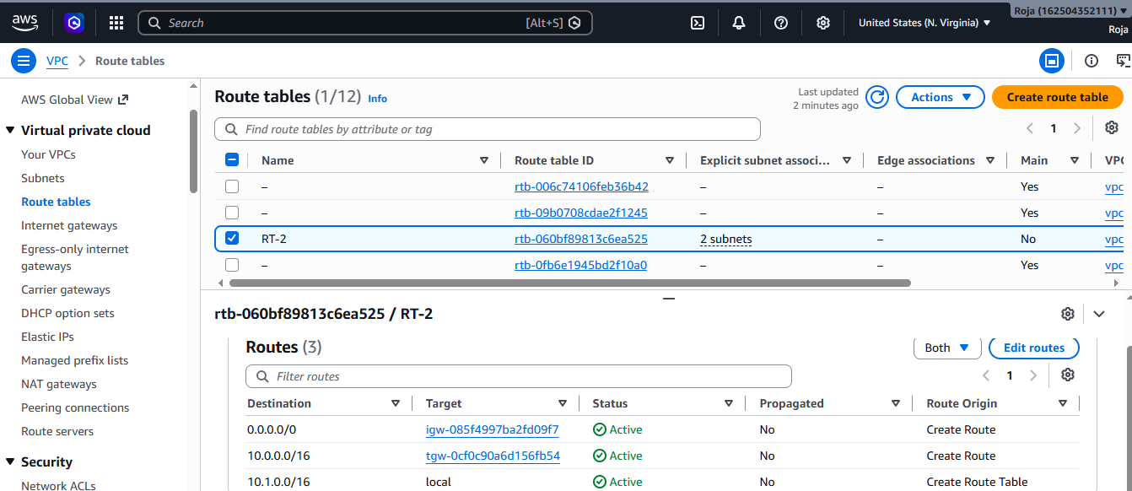
Update Route table-3 for VPC 3
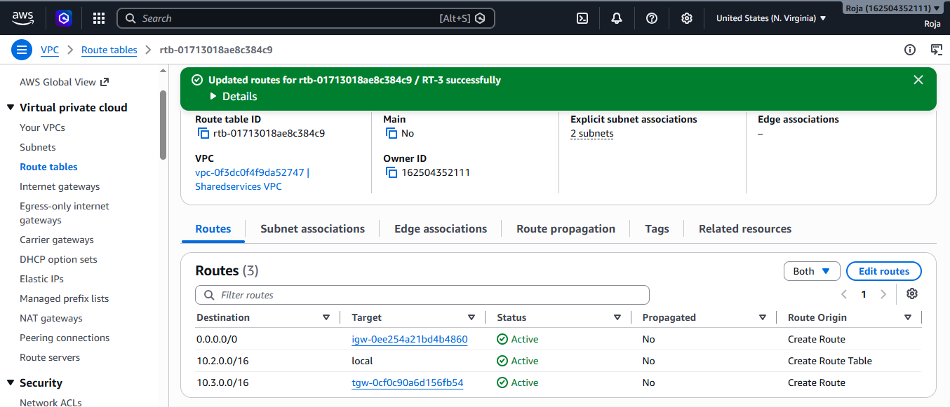

Step 8: Verify Transit Gateway Route Table
- Open Transit Gateway Route Tables.
- Select the default route table.
- Verify that all three VPC attachments are listed.
- Ensure routes have been propagated.
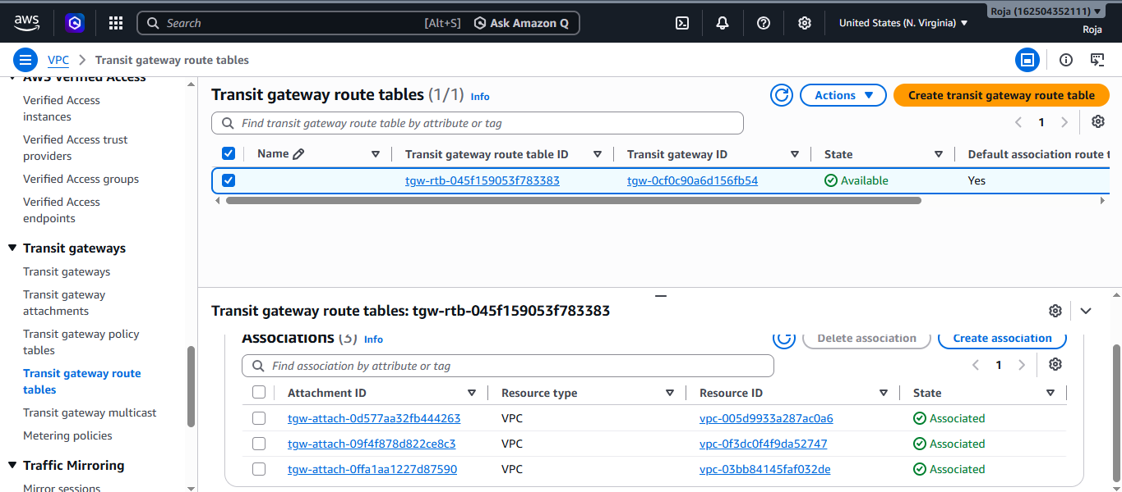

Step 9: Create a Gateway VPC Endpoint
Create an endpoint in each VPC (or at least the Application VPC).
- Open VPC → Endpoints.
- Click Create Endpoint.
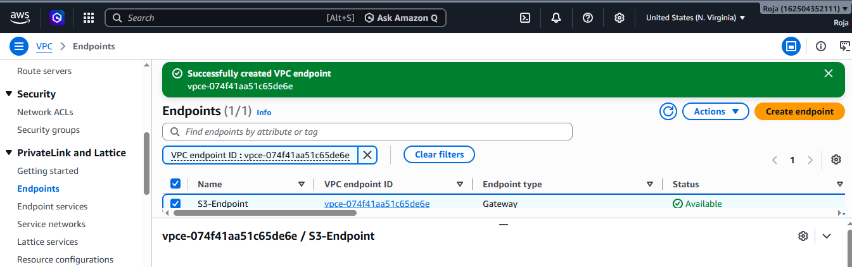
Verified route table to see pl-63a5400a entry is the Amazon S3 managed prefix list.

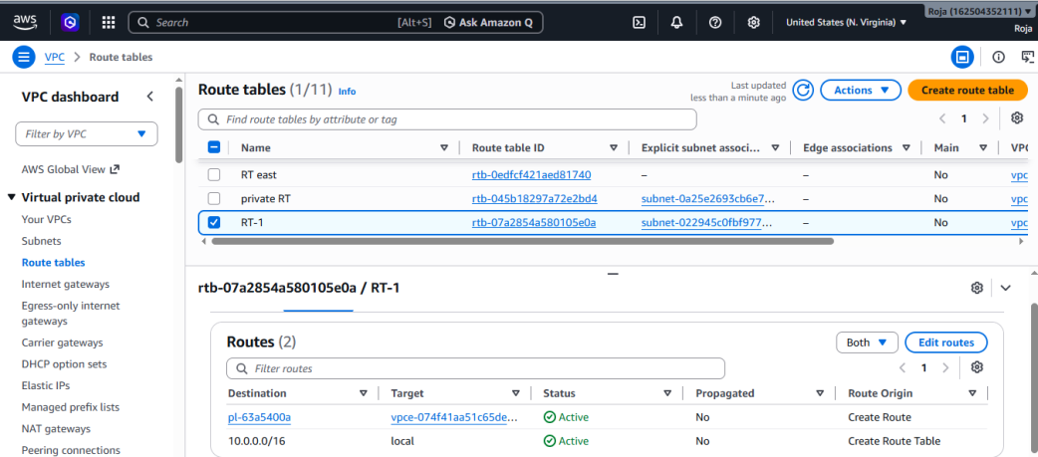

Step 10: Test Connectivity
Launch one EC2 instance in each VPC.
- Open the EC2 console.
- Click Launch instance.
- Connect to instance and check the connectivity.
Launched EC2 instance for VPC 1 :
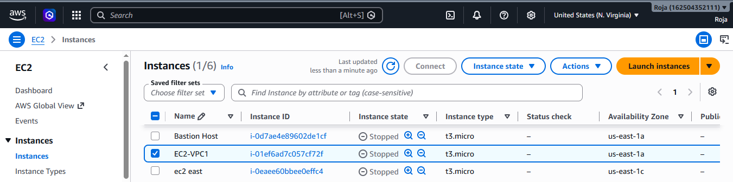
Connected to EC2 using ssh -i Pemkey.pem ec2-user@<publicip> and as connection is successful this shows that now I’m in EC2-VPC1
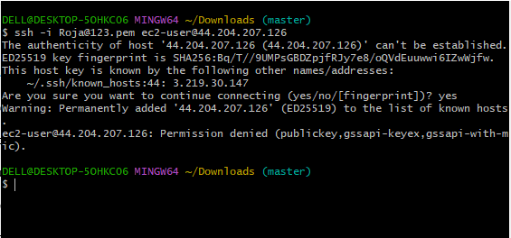
From the EC2-VPC1 terminal checking ping of EC2-VPC2
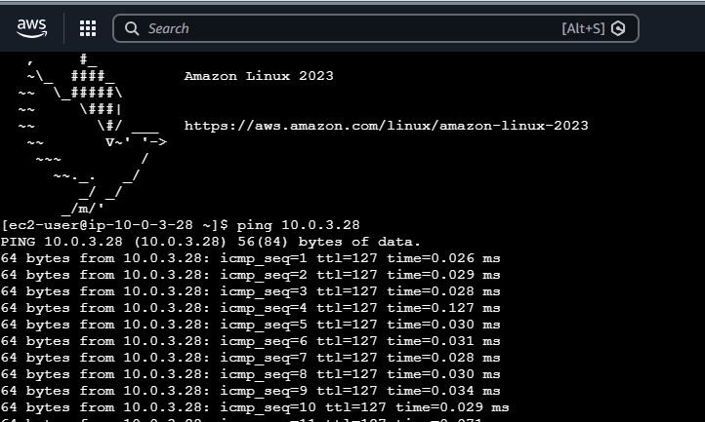
Launched new instance and verified the connectivity for VPC2
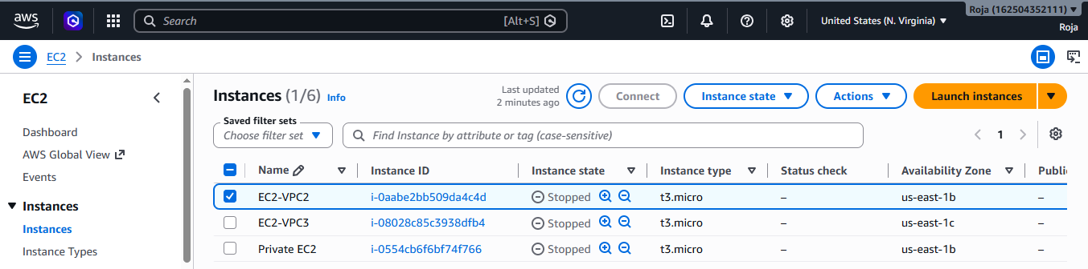
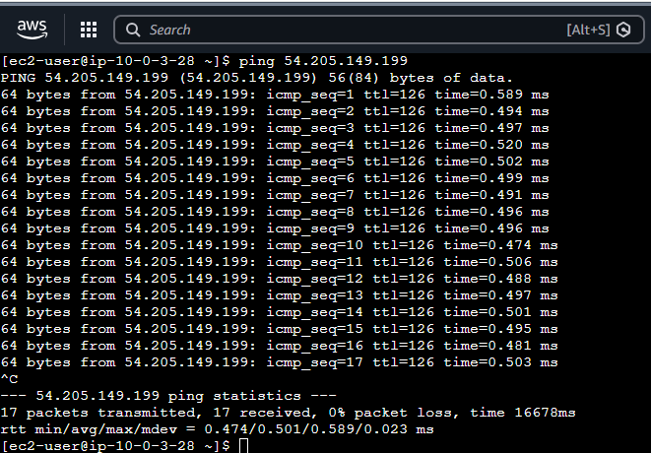
Launched new instance and verified the connectivity for VPC3
